Statement of intent

‘Improving attendance is everyone’s business. The barriers to accessing education are wide and complex and are often specific to individual pupils and families’ (Working together to improve school attendance 2024)

We have this policy because we believe that attendance in the Early Years is important and want to ensure early years children have the best start possible in their early education

We know it is not statutory in the Early Years and Childcare sector but there are so many good reasons why attendance is so important:
➢ The best opportunities for social development, including making friends and learning how to get on with others building on self-esteem.
➢ The best opportunities for children to learn and develop their skills and learn through play, this includes early language, reading and maths skills
➢ The development of good habits for future school attendance and good attendance and punctuality skills into adulthood.
➢ Underachievement is often linked to lower attendance.
➢ Children who attend every planned session develop a feel for the rhythm of the week and gain a sense of security from the regular elements of early years routines.
➢ Young children find it easier to build and sustain a range of social relationships.
- Children who regularly miss sessions or are generally late, can frequently experience a sense of having to try a little bit harder just to understand what is going on and what other children are talking about or doing.
- Practitioners carefully plan every session for each child in their care and want to take every opportunity to help them thrive; experiences gained in one session are often developed further in following sessions.

This policy sets out the procedures to be followed, when a child is absent from pre-school and how we are monitoring and supporting good attendance at Ladybirds Pre-school

Procedure

- The Manager and/or Deputy Lead are responsible for monitoring absence and following up any concerns raised by the team. We log absences on tapestry for each child and audit attendance across each half term for every child, aiming for 95 % attendance

- It is the responsibility of all staff to report to the Manager/Deputy each day regarding lateness/absence or if a child leaves our setting unexpectedly.

- If your child is sick or cannot attend pre-school, we ask that you call, text (Parkside setting only) or email us before 9.30am that day to let us know with a reason and we log this, and discuss any restrictions on return if a certain illness. If we have not heard from you, we will make contact to establish a reason for absence

- If we cannot get hold of you after several missed sessions, we will use your emergency contacts to establish contact and may contact other professionals (Health Visitor/Siblings schools/ family Social Worker, particularly in the cases of our more vulnerable families) to ensure you and your child are safe.
- We will consider patterns and trends in a child’s absences and their personal circumstances and use our professional judgement when deciding if the child’s absence should be considered prolonged.

- If there is a Safeguarding concern the Manager and/or Deputy, would follow our Safeguarding procedure and phone Children’s Resource Service (see our Safeguarding Policy).

- If you are planning holidays during term time you must let us know in advance so we can record this in our register.

- Fees remain payable during periods of absence, unless alternative arrangements have been agreed.

- We must notify Southampton City Council where children in receipt of Early Years Free Entitlement are absent for more than 2 weeks in a term.

The Importance of Maintaining and supporting good attendance

We need to ensure that we give children every opportunity to get the best start in life and to develop positive attitudes and skills to support them to be prepared for success in formal education and work in later life.

If parents are having difficulties getting their children to pre-school on time/for the sessions they are booked in for, we would like to ensure we are open to conversations and offer ideas to support better attendance (ie flexible start, changing days) to ensure they can come in regularly. These are conversations we would have with parents as patterns of absence occur or attendance has dropped.

As a setting, when children attend regularly, we have better opportunities to:
• Ensure children’s safeguarding and wellbeing
• Build relationships with the child & family
• Identify gaps in learning and any additional needs
• Plan activities to meeting the needs of the child
• Extend children's learning in a meaningful way

For parents, when your child attends regularly, you will have better opportunities to:
➢ Build a relationship with the early years’ settings, so you can discuss things that may impact on your child’s learning and development, and to be able to celebrate moments of achievement together.
➢ Discuss concerns with Early years settings which may lead to early identification of needs.
➢ To find out where you can gain support for yourself or your child. Early years settings have access to information where they can signpost parents to appropriate services when needed.
➢ Gain support and identify any gaps in your child’s learning and any additional needs they may need further.
➢ To gain ideas to support your child’s behaviour and learning at home, and different places or activities you could take them to.

Below is a useful diagram that shows in days and hours what attendance may look like if a child is on 15 hours funding. There are 190 days in an academic year which leaves 175 unfunded days for holidays, appointments and other fun activities therefore we encourage parents not to make these arrangements during their child’s funded hours. For children who attend an all-year-round provision then parents can take holidays etc. in term time as they can make up the hours at other points in the year.

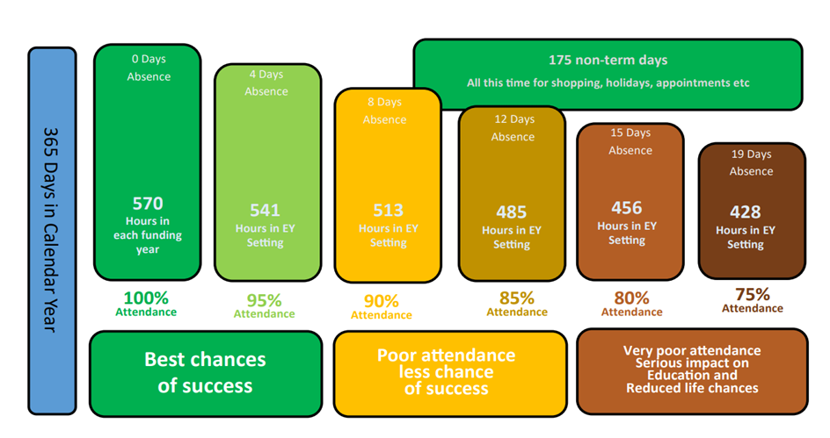
The diagram is also a reminder of how many hours a child misses when a child has a specific percentage of attendance. So, 95% attendance would mean that a child misses nearly two weeks of early years education which potentially could have an impact on the child’s learning.

Good early years attendance supports children's all-round development. If you have difficulties in attending regularly, or on time, please speak to your childcare provider as they will be happy to offer ideas and support to help give your child the best start in life.

Document ID- | Policy adopted at meeting – Apr 2016 | Reviewed by : Ladybirds Directors
Date reviewed | Feb 2018
Sept 2017 | 21/10/2019
Dec 2018 | July 2021 | Reviewed 21/03/2024
 |  | Updated 28/3/2025 JP and ZMH
 |  | ZMH 20/08/2025 revised EYFS
 |  | JP Oct 2026

