Ladybirds
Pre-School
At Porchester

Welcome Pack
(updated Feb 2024)

Ladybirds Pre-School
The Scout Hut
Porchester Road
Woolston
Southampton
SO19 2JB Tel: 02380 431226

You can find out more information and keep up to date with news at www.ladybirdsrus.co.uk
You can also find us on
Email: Ladybirdspreschool@hotmail.co.uk

Correspondence Address
C/O Ladybirds Pre-School (Porchester)
Festival Hall
Merryoak Road
Southampton
SO19 7QR

Opening Times and Fees

Morning Session – 8.45-11.45am Lunch time session – 11.45-12.30 Afternoon Session – 12.30-3.30pm

We can take children from 2 years 4 months of age dependant on spaces and staffing ratios. Children may be eligible for 2 year old funding dependant on strict criteria. If they are not you are able to pay for sessions. From April 2024 all 2 year olds should be eligible to get funding, please see the gov.uk website for applying

Funded 3 year old children are entitled to between 5 – 10 sessions a week, depending on if you are eligible for 15 or 30 hours funding. Children will be funded the term after they turn 3 years of age. We do offer the opportunity for you to pay for more sessions above your 15 hours funded entitlement at a cost of £18.00 per session. Please talk to the Manager for more details. Lunch club is charged at £4.50 a day, unless your funding covers this.

We can cater for the 30 hour funding, please see the Manager with your eligibility code, or follow the link below to check your eligibility www.childcarechoices.gov.uk

We offer our sessions flexibly as follows
- Five sessions in the mornings
- Five sessions in the afternoons
- Five sessions over 2 and half days
- Full time Mon-Fri (30 hour funding)
- We can also accommodate a mixture of mornings and afternoons
- Extra sessions above funded hours can be offered and this will incur a session charge at the 3/4 year old fee.

Fees

An invoice will be issued via an online portal, prior to the commencement of you starting. Full payment for that month should be made before or on the day the child starts at the pre-school. Individual payment plans are available on request if you wish to pay by instalments. Late or non-payment of fees may result in your child’s place being withdrawn and offered to another child. All fee paying families will be required to read and sign our Non Payment of Fees Policy to confirm that you understand and will work in line with the policy. All fees must be paid in advance each month.
If you no longer require any sessions, you must give 4 weeks written notice of your required change. If you are leaving the setting, 4 weeks written notice is also required. All fees are due until the end of the 4 weeks and must be paid in full. Please see our Fee Paying policy for more details.

Lunch Time Sessions

Charged at £4.50 per session (if above funded hours)
Lunch sessions can be taken within your 15/30 hours funding. (For example a funded child can attend 2 full days and claim only 13.5 hours of funding instead of 15)
We offer a lunch time session starting at 11.45 and ending at 12.30. Children will need to be provided with a healthy lunch e.g. sandwiches, fruit and yogurt and a drink. Please do not send your child in with sweets or chocolate bars as we promote healthy eating in our setting. (Please refer to Healthy Eating Policy on our website) We are also a NO NUT setting (including Nutella/hazelnut products) You will also need to mark your child’s lunch box clearly with their name. All fees should be paid in advance of when they are due.

Ladybirds Porchester Mission Statement

Ladybirds Pre-school works to provide a safe, caring and stimulating environment where children learn through play, both in and out of doors.
The curriculum, planning and timetable are planned, using the ‘Early Years Foundation Stage and Birth to Five Matters’ and the “Plan, Do, Review” cycle from ‘High Scope’ educational approach to learning.
Ladybirds Pre-School has a high ratio of adults to children, 1 adult to 3 children under 3 years old and 1 adult to 6 children over 3 years, this enables us to:
- Give time and attention to each child
- Talk with the children about their experiences, interests and activities
- Help children to experience and benefit from the activities provided
- Allow the children to explore and be adventurous in a safe environment

The Session
As a team we are committed to an active learning environment so that children are able to follow their interests, and are able to take safe risks and challenges. We provide this through:
- Careful planning of the environment, materials and experiences with the children’s interests and stages of development in mind
- organising space both in and out of doors into interest areas
- plentiful materials, clearly labelled, we have a book showing what other boxes we have out in the store so children can chose another box if they wish, for the children to use and return
- Adults interact and support children sensitively throughout the session focusing on their strengths as children work on age appropriate experiences. As children’s confidence grows they are able to form authentic relationships with both adults and children.
- Where conflict arises we use a problem solving approach
- A consistent daily routine ensuring that children have time to follow through their plans and ideas in a secure, caring and supportive environment.

Our Routine

- Welcome – all staff and children gather together to welcome each other and share any special news
- Small Group Time – the adult selects materials based on the children’s interests and needs from information gained through observations, the seven areas of learning and local events
- Plan – to express their interests and intentions, they make decisions and plans
- Choosing Time – carry out their plan with the supportive adult team both in and out of doors.
- Tidy Up Time – children and adults work together to sort and put back the materials used during work time
- Remembering Time – look back at what they did maybe using words, drawing, the work created and use fiddles and photo bags to help with this process
- Large Group Time – where children and adults come together to work together on a group theme e.g. books, music and movement, games, role playing and dancing

Through this consistent, but flexible routine the children have control of their time and they are secure in the knowledge that they can plan, carry out an activity/s and reflect on what they did. Use of a 5 minute warning before snack cafe is closed and 5 minutes warning before tidy up time helps the children manage their own time and choose when to visit the snack cafe for example. Even the newest members of the pre-school quickly develop understanding of the routine secure in that they know what will happen next.
Through the plan-do-review process we enable children to think, experiment and make choices giving them ownership of their time. We value the children’s contributions and ideas and use this as the starting point for our planning. This in turn builds children’s confidence and self-belief, allows them to take risks and learn to persevere in their learning in a supportive environment.

Working with Parents:

The pre-school staff and Directors work together as partners, promoting parental involvement. Parents are recognised as the children’s primary educators. We regularly consult with the parents either verbally or through questionnaires/surveys as we value their opinions and this helps us to provide a better service. Within the pre-school setting we provide support for parents in the forms of notices and a parent information point on local services, healthy eating, language tools, books of interests etc. With the use of the online journals “Tapestry” we are able to share learning, support ideas and get instant feedback.

We strive to support families and parents by:
- Visiting you and your child at home just before your child starts at pre-school
- Valuing all parents equally
- Meeting with parents at all times convenient to them
- Keeping all information confidential unless abuse is suspected
- Talking through the possibility of involving outside agencies where appropriate and only with parental consent, unless abuse is suspected
- Having a trained SENDCO (Special Educational Needs & Disability Co-Coordinator) to liaise with outside agencies, plan and oversee the activities carried out with individual children who require extra support or have a special educational need/disability
- Up to date information on our parents board

You can take part in our pre-school in the following ways:
- Helping at pre-school sessions or just coming in for a play!
- Helping provide, make and look after the equipment and materials used
- Being part of the Pre-school Parent Forum
- Taking parts in events and community activities in which the pre-school either holds and takes part in
- Building friendships with other parents in the pre-school
- Attending meetings, outings and fundraising activities
- Grandparent Days, Mother and Father Day events, trips and fundraisers.…the list is endless

Ladybirds Pre-school Parent Forum

We have two tiers to the set -up of our pre-school, where we are run by a board of Directors; made up of the two Managers and other Senior members, we manage the pre-school and look at the legal elements and the day to day running, including forward planning. We then have a Parent Forum which is made up of parents from both settings and all parents are invited to join it. Here you can make plans for fundraising events, pre-school trips and have an influence over what happens in the settings. Each year an Annual General Meeting is held where the Directors will inform you about the previous years’ events, finances, discuss new policies that we have to follow staff update and the partnership work. Meetings are held normally during pre-school session times at a parent’s home about once a month. By joining the Parent Forum you will be able to help make decisions in fun events/fundraising the Pre-school will be involved in.

Key Persons

Each child and their parents/carer are allocated a key person on entry to the pre-school. The key person will work with their key children on a daily basis through planning, remembering, and small group time and will develop a strong bond with these children getting to know their interests and stages of development well. The team have regular meetings and discussions to ensure that relevant information is shared with everyone, meaning that each child receive the highest quality care and education, unique to them. The key person will work with parents/carers to make sure that the pre-school provides for your child’s particular stage of development and interests. This starts at the home visit and continues with regular observations on Tapestry (online journal) and then twice a year at parent consultations to discuss their child’s next steps. The key person also discusses next steps and developments with any other setting a child maybe attending.

Ofsted
We had our inspection in March 2022, and we’re very proud to be awarded an ‘Good’ overall. This inspection focused on the following areas of Pre-school life; What is it like to attend this early years setting? What does the early years setting do well and what does it need to do better?, Safeguarding, The Quality of education, Behaviour and attitudes, Personal development and Leadership and Management.

Beginning of Session:

At the beginning of both the morning and afternoon session you need to enter the setting through the gate on Porchester Road. Please try to walk to pre-school with your child as you will find parking very difficult in this area. If you need to come into pre-school during the session, and no-one is in the garden, please phone the pre-school on 02380431226

As you arrive with your child you can help them to hang up their coats/bags etc on their individual name hook and find their photo to say register. The children choose from a small selection of activities, then we gather on the carpet for welcome time.

The Session

Please refer to the ‘Daily Routine’ in this this pack for details of our session.
The activities and routine are planned, using the Birth to five Matters Framework and the revised EYFS. The Birth to Five Matters is the non-statutory guidance we have chosen to follow for children aged 0-5 years. There are seven areas of learning and development that shape the educational programmes in early year’s settings. All areas of learning and development are important and interconnected. The Birth to Five Matters has four themes; A Unique Child, Positive Relationships, Enabling Environments, Learning and Development which underpins the whole guidance. Children in the EYFS learn by playing and exploring, active learning, creating and thinking critically which takes place both indoors and outside (our planning must reflect the different ways children learn). At Ladybirds we work hard to ensure that the characteristics of effective early learning and themes are embedded in our everyday practice and routine.

The seven areas are divided in prime and specific areas as follows;

The prime areas; At some point after your child turns 2, your child’s key person will give you a written summary of how your child is progressing against the three prime areas. This is called the progress check at age 2. This check will highlight areas where your child is progressing well and anywhere they might need some extra help or support.

Communication and language is made up of the following aspects:

Listening and attention: children listen attentively in a range of situations. They listen to stories, accurately anticipating key events and respond to what they hear with relevant comments, questions or actions. They give their attention to what others say and respond appropriately, while engaged in another activity.
Understanding: children follow instructions involving several ideas or actions. They answer ‘how’ and ‘why’ questions about their experiences and in response to stories or events.
Speaking: children express themselves effectively, showing awareness of listeners’ needs. They use past, present and future forms accurately when talking about events that have happened or are to happen in the future. They develop their own narratives and explanations by connecting ideas or events.

Physical development is made up of the following aspects:
Moving and handling: children show good control and co-ordination in large and small movements. They move confidently in a range of ways, safely negotiating space. They handle equipment and tools effectively, including pencils for writing.
Health and self-care: children know the importance for good health of physical exercise, and a healthy diet, and talk about ways to keep healthy and safe. They manage their own basic hygiene and personal needs successfully, including dressing and going to the toilet independently.

Personal, social and emotional development is made up of the following aspects:

Sense of self: children are confident to try new activities, and say why they like some activities more than others. They are confident to speak in a familiar group, will talk about their ideas, and will choose the resources they need for their chosen activities. They say when they do or don’t need help.
Understanding Feelings: children talk about how they and others show feelings, talk about their own and others’ behaviour, and its consequences, and know that some behaviour is unacceptable. They work as part of a group or class, and understand and follow the rules. They adjust their behaviour to different situations, and take changes of routine in their stride.
Making relationships: children play co-operatively, taking turns with others. They take account of one another’s ideas about how to organise their activity. They show sensitivity to others’ needs and feelings, and form positive relationships with adults and other children.

As your child grows, the prime areas will help them develop skills in the 4 specific areas. These are:

Literacy is made up of the following aspects:

Reading: children read and understand simple sentences. They use phonic knowledge to decode regular words and read them aloud accurately. They also read some common irregular words. They demonstrate understanding when talking with others about what they have read.
Writing: children use their phonic knowledge to write words in ways which match their spoken sounds. They also write some irregular common words. They write simple sentences which can be read by themselves and others. Some words are spelt correctly and others are phonetically plausible.

Mathematics is made up of the following aspects:

This involves children developing their own understanding of number, quantity, shape and space. This involves experiences of seeking patterns, creating and solving mathematical problems and engaging with stories, songs, games and practical activities. Children have a natural interest in quantities and spatial relations, this curiosity and enjoyment should be nurtured.

Understanding the world is made up of the following aspects:

People and communities: children talk about past and present events in their own lives and in the lives of family members. They know that other children don’t always enjoy the same things, and are sensitive to this. They know
about similarities and differences between themselves and others, and among families, communities and traditions.
The world: children know about similarities and differences in relation to places, objects, materials and living things. They talk about the features of their own immediate environment and how environments might vary from one another. They make observations of animals and plants and explain why some things occur, and talk about changes.
Technology: children recognise that a range of technology is used in places such as homes and schools. They select and use technology for particular purposes.

Expressive arts and design is made up of the following aspects:

Creating with materials: children sing songs, make music and dance, and experiment with ways of changing them. They safely use and explore a variety of materials, tools and techniques, experimenting with colour,
design, texture, form and function.
Being imaginative and Expressive: children use what they have learnt about media and materials in original ways, thinking about uses and purposes. They represent their own ideas, thoughts and feelings through design and technology, art, music, dance, role-play and stories.

These 7 areas are used to plan your child’s learning and activities. Your child’s key person will make sure that the activities are suited to your child’s unique needs. It is designed to be really flexible so that we can follow your child’s unique needs and interests and share on to your online journal. Twice a year we will invite you in for a parent consultation, where we can discuss your child’s learning and development and how together we can support and meet their next steps. But you can ask to talk to your child’s key person at any point during their time with us.

Snacks
The pre-school provides a healthy snack for the children, which children and adults have together at our snack cafe which is open during ‘Choosing Time’. The children take an active part in snack time giving out cups and pouring their own drinks, use knives to make sandwiches. They make choices and solve problems i.e. we only have 2 pieces of apple left what shall we do? Snack time is also a learning opportunity at Ladybirds we count, predict, estimate, choose, and learn about table manners. The snacks provided for the children are healthy and nutritious. The food reflects different cultures and eating habits i.e. we have noodles and chopsticks, Polish bread, pitta bread, different types of fruit. We work in close consultation with parents to meet special dietary needs.

Please ensure that your child has had a healthy breakfast or lunch before coming to pre-school. Children need regular meal times with a variety of foods for a balanced and healthy life style. Plenty of fresh fruit and vegetables are vital for a healthy life. At pre-school we sit together at a table to eat and do not wander around with food or drink. We find this a great time to talk as I am sure you do at home.

At pre-school we offer either milk or water as squash is not good for children’s teeth. Please try to avoid sugary drinks like squash and fizzy drinks, as these are not good for children.

End of Session:

We will open the gate to let parents in to collect or drop off children at 8.45, 11.45, 12.30 and 3.30pm. If you need to gain access at any other time please call the Pre-school on 02380 431226 so we can open the gate for you. Whilst we appreciate that there may be times when due to traffic etc you may be a few minutes late collecting your child, it is vitally important that you are on time. Once the session ends we are not insured to have your child on site and we do reserve the right to charge if you are persistently late. The charges are £10 for first 15 minutes, £5 every 5 minutes thereafter.

Special Needs
As part of our policy we make sure that the special needs of a child are taken in to account. The pre-school works to the requirements of the Education Act and the Special Education Needs Code of Practice. We have a trained and very experienced SENDCO who will work closely with you, our Area SENDCO (Early Years Advisory Teacher) and outside agencies to meet the needs of our children. A copy of our SEN policy is available, please ask a member of the team.

Sickness and Medication
We believe that the health of our children is of paramount importance and as such have adopted the guidelines as issued by the Health Protection Agency. Under these guidelines if a child has sickness or diahorrea they must not come back to pre-school until 48 hours after their last bout. If you have given calpol to your child for a temperature or to reduce the affects of coughs/colds, please can we ask that you keep them at home until they are well enough to be at pre-school
We are able to administer prescribed medicine from a doctor once your child has been taking it for 48 hours.

Clothing
Uniform is not compulsory but does give the children a sense of belonging. New uniform can be purchased from on line. https://myclothing.com/ladybirds-pre-school/9964.school

We will provide protective clothing for children when they play with messy activities but we advise you to dress for mess as we do not want to inhibit the children’s creativity by worrying about getting mucky. We encourage children to gain the skills which help them to be independent and look after themselves, these include taking themselves to the toilet, taking off and putting on outdoor clothes. To build confidence and independence it is important that clothing is easy to use e.g. elasticated waists rather than belts and buttons. For outdoor play during the autumn/winter months we will provide waterproof clothing as we access outdoors in all weathers. Please ensure your child’s clothes are clearly named to avoid confusion. Earrings must be studs. Hoops or long earring must be removed prior to the session starting.

Outings

When and where possible we do arrange outing for the children including an end of year school trip. When running trips parents (or another responsible adult) are normally required to attend but more information will be supplied for each trip.

Time for Your Child

At Ladybirds we are taking part in the Every Child a Talker project. This is a government initiative to
raise standards of language and communication skills in our children as they have showed a marked deterioration in recent years. As part of this project we have our book library to encourage communication through play between parents and children. Children need to be listened to and talked with. The more you talk with your child the better they will learn to speak and communicate. Getting out for a walk costs nothing and is an ideal time to have a chat with your child, try and get them out of the buggy to burn off some of that energy. If your child still has a Dummy, get rid of it or at least ensure that they do not have it in their mouth when they are speaking. If children learn to speak with a Dummy in, they are not learning to form the sounds for words correctly. Talk as you do things together and respond positively; sing songs and rhymes together and read stories often.

Policies

All staff and students are required to read the pre-schools adopted policies when receiving their induction training. The staff team are regularly assessed using an appraisal system and required to attend appropriate training courses.
The pre-school has adopted a list of policies, copies of which are located on the Parents Board in a folder labelled Policies, copies can be obtained on request from the pre-school staff, and can be found on our website.

What to bring to Pre-School each day for my child

Please could you provide the following items for your child when they come to Pre-school, in a named bag. This bag will need to go home each day as we have no-where to store them at the end of the sessions. Children should wear clothes to Pre-School suitable for active and messy play. We do provide aprons and waterproofs but at times theses do not protect from all spills or messy play. However we do have a Pre-school uniform of jumpers and polo shirts you can purchase these from the link above.
- Full change of clothes: Including pants and socks (your child may get wet outside or when playing in the water tray, or get covered in paint)
- Wellie Boots for outside play, and a pair of shoes for inside as their boots will get muddy from outside, and it is unsafe to be inside in just socks
- Named bottle of sun cream (Summer Term)
- Named sun hat (Summer Term)
- Suitable outdoor coat (even if you travel to school in the car as the children have access to outside play throughout the sessions)
- Hat, gloves etc (Winter/Spring Term)
- Nappies, wipes, cream (if needed) and nappy sacks for the day

Please ensure all items are clearly labelled with your child’s name

Staff Officer Roles

SENDCO (Special Educational Needs & Disability Co-ordinator)
Zoe Marler-Hausen

Designated Safeguarding Lead (DSL)
Zoe Marler-Hausen and Theresa Quartermaine

Equality & Diversity Officer
Gillian McCarthy

Food, Nutrition, Hygiene & Cleanliness Officer
Jade Cavill (Healthy Eating Lead)

Health & Safety Officer
Theresa Quartermaine (Physical Activity Lead HEYA)

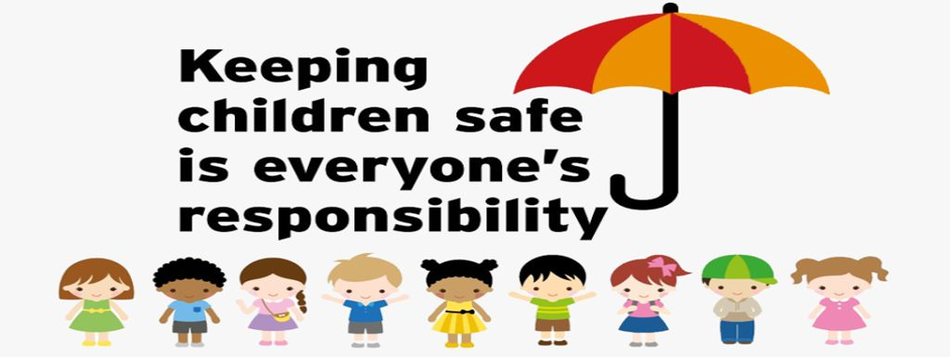

Introducing our Designated Safeguarding Leads……………….

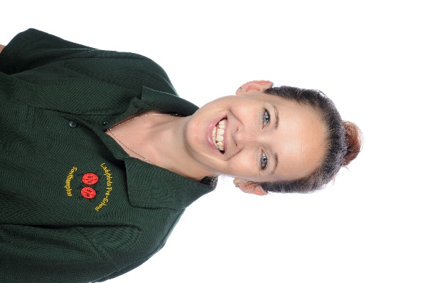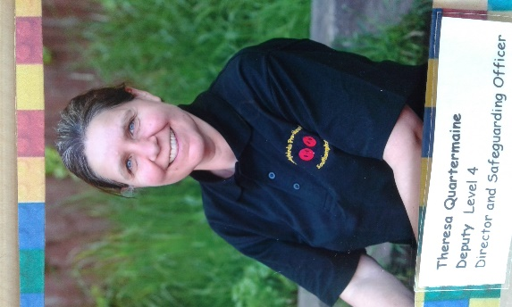
Zoe Marler-Hausen Theresa Quartermaine
In line with our Safeguarding Children Policy, our role includes:
Safeguarding and promoting the welfare of children
Preventing the impairment of children’s mental and physical health or development;
Ensuring that children grow up in circumstances consistent with the provision of safe and effective care;
Taking action to enable all children to have the best outcomes.
If you have a concern about a child’s welfare or safety please come and speak to us immediately.

