Ladybirds
Parkside Preschool

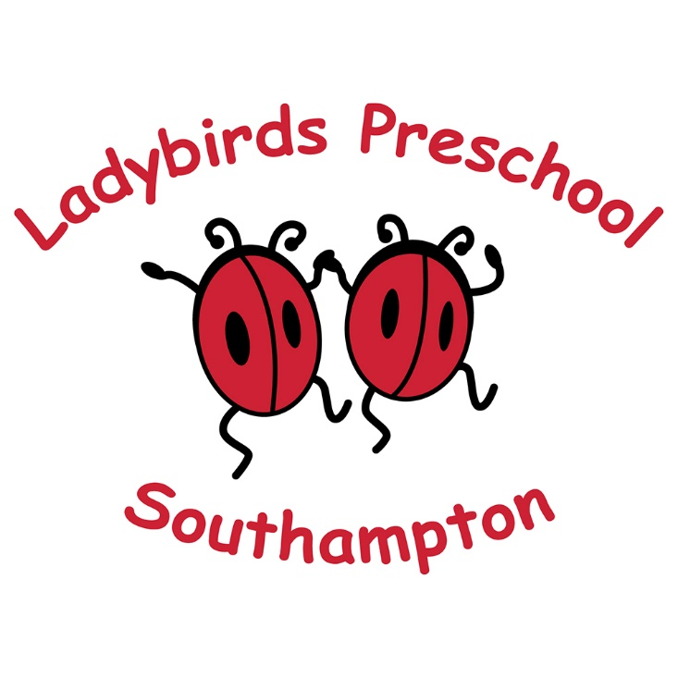
Welcome Pack

Welcome to Ladybirds! We are thrilled that you have chosen our preschool for your child’s early years journey. This pack contains lots of useful information, but if you have any questions or we’ve missed anything at all, do let us know – we are always happy to help.

Ladybirds Parkside Preschool
The Festival Hall
Merryoak Road
Bitterne
Southampton
SO19 7QR

Tel: 02380 447997
Mobile: 07588049737

You can find out more information and keep up to date with news at www.ladybirdsrus.co.uk
You can also find us on - by searching Ladybirds Parkside Preschool

Email: ladybirdsparkside@outlook.com

We are a Registered Charity (number 1139080) and a Limited Company (registration number 7381763)
Our Ofsted registration number is 2531700

Contents

Information | Page number
Setting name, address, registration details | 1
Website/Facebook/email/telephone numbers | 1
All about Ladybirds - background | 3
Opening times/sessions | 4
Fees/Funding and How to Pay | 4
Our missions statement and aims for children | 5
Routines and daily content | 6/7
Plan/do/review | 8
Key person/Co-person | 8

Contents (continued)

Information | Page number
Working in partnership with parents | 9
How parents can be involved in preschool | 10
Giving Tree and snack donations | 10
Equipment and uniform | 11
Arriving at preschool | 11
Helpful tips and things to remember | 12
Management team/ Key person and Co-person | 13
Notes/questions or comments section | 13

All about us!

Ladybirds Preschool is a Limited Company with Charitable Status that has been providing high quality early years care and education for over 15 years!

The Charity and Company is overseen by a group of Company Directors and Charitable Trustees made up from current and previous parents of Ladybirds children, and management staff members who manage the preschools and all the legal elements and the day to day running, including forward planning.

We also have a Parent Forum which is made up of parents from both settings and all parents are invited to join it. Parents can make plans for fundraising events, pre-school trips and have an influence over what happens in the settings. Each year an Annual General Meeting is held where the Directors will inform all parents about the previous years’ events, finances, discuss new policies that we have to follow staff update and the partnership work. Parent Forum meetings are usually held during preschool session times in a room in the Festival Hall (adjacent to the preschool room). When circumstances prevent these types of meetings happening (e.g., the Coronavirus Pandemic) we find alternative ways to communicate – e.g., Zoom meetings. By joining the Parent Forum parents and carers can help make decisions in fun events/fundraising the preschool will be involved in.

Ladybirds Parkside Setting

Ladybirds Parkside Preschool opened in September 2019 when the Ladybirds preschool at Ludlow Infant Academy needed to relocate to more spacious premises. A robust tender to secure the premises was successfully submitted and the move took place – we love our huge space and have never looked back!

We are based in a large community room at the Festival Hall in Merryoak Road, on the corner of the Veracity Green. We have a huge, fully secure garden which was redesigned in advance of our move to provide a large hardstanding area, 2 spacious storage sheds, 1 of which doubles up as an outdoor role play shed. We have lots and lots of outdoor space for the children to explore and physically develop.

In Summer 2020 we upgraded the garden to give 2 dedicated garden areas. We have an area designed for our younger children aged from 2 years with a toadstool story circle amid a natural area access by crossing our fairy tale bridge. The other area is dedicated to children in the year preceding school and has a challenging climbing frame with a double slide, a super wigwam and a basketball area and a lovely beach style area, with beach hut wooden walls and a real boat! Both areas are served by a bespoke wooden canopy, also added in Summer 2020 with a sail shade extension for sunny days. We are gradually developing growing areas in each of the 2 outdoor spaces so children can dig, plant and learn about growing whilst developing muscles. We often find that children are keen to start at Ladybirds, having spied the garden when passing!

Inside the room is also set up to give dedicated spaces for the two age group, each area being fully resourced for all areas of learning and development including; construction areas, home corners, making (art and craft) places, maths areas, small world areas and indoor movement areas in addition to story and role play areas where children can develop imaginations!

Opening Times Sessions and Fees

We are open from 8.30 am until 4 pm Monday to Friday during school term times. We offer a range of flexible session detailed below.

Option type | Start | Finish | Hours | Lunch | Cost (non-funded) – over 3 | Cost (non-funded) – under 3
- School day (SD) | 8.30 | 2.30 | 6 | yes | £30 | £24
- Extended day (ED) | 8.30 | 4 | 7.5 | yes | £37.5 | £30
- Mornings (AM) | 8.30 | 11.30 | 3 | no | £15 | £12
- Afternoons (PM) | 1.00 | 4 | 3 | no | £15 | £12
- Add-on lunch time session (L) | 11.30 | 1 | 1.5 | yes | £7.5 | £6

We are registered to accept children from 2 years of age, dependant on spaces and staffing ratios. We accept all types of funding in addition to paid for sessions. To find out more about the funding you may be entitled to check this website www.childcarechoices.gov.uk

Paying Fees
An invoice will be issued prior to the commencement of the term. Full or first payment should be made before or on the day the child starts at the preschool. Individual payment plans are available on request if you wish to pay by instalments. Late or non-payment of fees may result in your child’s place being withdrawn and offered to another child. All fees must be paid in advance either in full, or by instalments. We would prefer this to be paid via internet banking.
If you no longer require any sessions, you must give 4 weeks written notice of your required change. If you are leaving the setting, 4 weeks written notice is also required. All fees are due until the end of the 4 weeks and must be paid in full. Further details can be found on our Payment of Fees Policy on our website or emailed on request.
How to pay

Please pay by bank transfer giving your child’s name as reference and pay type e.g., Tom Jones – fees

Ladybirds Preschool Sort code: 08-92-99 Account: 65854958

Ladybirds Parkside Mission Statement – what are our aims for your children?

“Learning through wonder – developing together.”
Promoting inquisitive minds with
collaboration at the heart of learning.
Building a sense of community and inspiring
a life-long love of learning.

Ladybirds Preschool works to provide a safe, caring and stimulating environment where children learn through play, both in and out of doors.
The curriculum, planning and timetable are planned, using the Early Years Foundation Stage (EYFS) Statutory Framework and the “Plan, Do, Review” cycle from ‘High Scope’ educational approach to learning.
Ladybirds Pre-School has a high ratio of adults to children, 1 adult to 3 children under 3 years old and 1 adult to 6 children over 3 years.

Our skilled preschool practitioners support children’s development and confidence by:
- Giving time and attention to each child
- Talking with the children about their experiences, interests and activities
- Helping children to experience and benefit from the activities provided
- Allowing the children to explore and be adventurous in an environment where children can challenge themselves, learning to manage risks to keep themselves safe

Our environment

We have a vast garden and a spacious indoor area where children can explore, play and learn. Our indoor and outdoor areas are set out so that there are dedicated spaces for the younger of our children (Little Ladybirds) and for the older children (Flying Ladybirds).

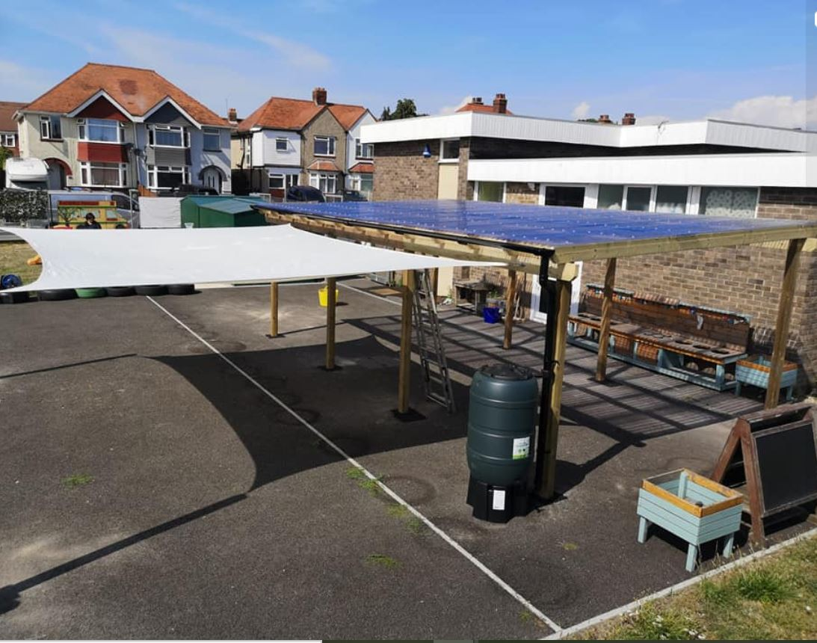

Routines

At Ladybirds we advocate consistent, flexible routines where children can become familiar with what happens next and thrive. Routines are slightly different for each age group and organised into sessions throughout the day. This gives flexible choices for parents, with familiar content for children, whatever sessions they might attend.

The Sessions
As a team we are committed to an active learning environment so that children are able to follow their interests and are able to take safe risks and challenges. We provide this through:
- careful planning of the environment, materials and experiences with the children’s interests and stages of development in mind
- organising space both in and out of doors into interest areas
- plentiful materials, clearly labelled, with regularly rotated resources based on children’s interests and needs.
- Adults interact and support children sensitively throughout the session focusing on their strengths as children work on age-appropriate experiences. As children’s confidence grows, they are able to form authentic relationships with both adults and children.
- A consistent daily routine ensuring that children have time to follow through their plans and ideas in a secure, caring and supportive environment.

The aspects of our routines

- Welcome Time – as children arrive in preschool they are welcomed with singing, music and movement, looking at books or tabletop activities. Children are also offered a healthy cereal snack on arrival. (Fruit or vegetable sticks are available throughout the morning if required)
- Sunshine circles - interactive group nurture activities designed by The Theraplay Institute to promote an atmosphere of fun, caring, acceptance and encouragement that leads to better social, emotional and even cognitive development
- Small Group Time – the adult selects materials based on the children’s interests and needs from information gained through observations, the seven areas of learning and local events
- Plan – to express their interests and intentions, they make decisions and plans and think about what they might need to support their plans e.g., put on a coat to go outside.
- Choosing Time – children can choose to play and carry out their plans, leading their play and learning with the supportive adult team both in and out of doors.
- Tidy Up Time – children and adults work together to sort and put back the materials used during choosing time
- Remembering Time – look back at what they did maybe using words, drawing, the work created and use fiddles and photo bags to help with this process
- Large Group Time – children and adults come together to participate in a group activity e.g. books, music and movement, games, role playing and dancing

A daily typical routine for a day at Ladybirds:

AM SESSION
8:25am- Welcome time: singing, music and movement, looking at books or table-top activities. Children are also offered a healthy cereal snack on arrival with fruit or vegetable sticks available throughout the morning if required.
8:50am- Sunshine Circles
9am – Small group time followed by planning time
9:15am- Choosing time inside or outside
11am- Remembering time
11:10am- Large group time
LUNCH SESSION
11:25am- Children going home to get ready/ Children staying for lunch to wash hands.
11:30am- Home time/ Lunch time
11:45am- Floor activities available as children finish lunch
12pm- Choosing time inside or outside (Children that go home at 1 get ready and do remembering time)

PM SESSION
1pm- Sunshine Circles (welcoming afternoon children)
1.10 – Small group time followed by planning time
1:15pm- Free flow inside or outside
2.20 Remembering time for children that go home
2:30pm- School day children home time
2:40pm- Free flow inside and outside during which
- PM snack is offered to children
3.25 - remembering time
3:35pm- Large group time
3:50pm- Getting children ready for home time
Routines may vary slightly for younger children or at the when children start preschool, for example small group times may take place after choosing time if children need time to wriggle, run and explore before engaging with more focussed activity. Through these consistent, but flexible routines the children have control of their time and they are secure in the knowledge that they can plan, carry out an activity/s and reflect on what they did. Use of five-minute advanced warnings before any transition times e.g. tidy up time, helps the children process and manage their time. Even the newest members of the preschool quickly develop understanding of the routine secure in that they know what will happen next.
Plan/do/review – how does this help children learn?

Our ‘plan-do-review’ process children develops skills for thinking, experimenting and make choices giving them ownership of their time. We value the children’s contributions and ideas and use this as the starting point for our planning. This in turn builds children’s confidence and self-belief, allows them to take risks and learn to persevere in their learning in a supportive environment.

Children attending at Lunch Time

Lunch times are a wonderful opportunity for children to develop essential life-skills, independence, peer relations and communication to name but a few! Please provide your child with a healthy lunch e.g., sandwiches, fruit and yogurt and a drink. Please do not send your child in with sweets, fizzy drinks or chocolate bars as we promote healthy eating in our setting. You will also need to mark your child’s lunch box and any containers clearly with their name. All fees should be paid in advance of when they are due. It’s a good idea to practise opening containers as they often like to do this for themselves. We provide water and milk in jugs and cups for pouring.

During the Coronavirus pandemic we are also requesting that children bring a named water bottle when they start at Ladybirds. We will keep this at preschool and ensure it is cleaned and kept topped up with water.

Key Persons/co persons

Each child and their parents/carers are allocated a key person on entry to the preschool. The key person will work with their key children on a daily basis through planning, remembering, and small group time and will develop a strong bond with these children getting to know their interests and stages of development well. The team have regular meetings and discussions to ensure that relevant information is shared with everyone, meaning that each child receive the highest quality care and education, unique to them. The key person will work with parents/carers to make sure that the preschool provides for your child’s particular stage of development and interests. This starts at the home visit and continues with regular observations on Tapestry (online journal) and then twice a year at parent consultations to discuss their child’s next steps. The key person also discusses next steps and developments with any other setting a child maybe attending.

We are sensitive to child led connections with trusted adults and may change a key person if this is in the best interests of the child. In addition, we allocate a ‘co-person’ who may be the best person to support a key child should their key person not be available. However, we are a welcoming and supportive team and find that children are soon confident with all of the staff team in addition to their ‘special person’ – their key person.

Working with parents and gathering essential information

At Ladybirds we recognise that parents/carers are the most enduring educators and experts of their children. To help us get to know your children we offer a range of settling and information gathering events. Where possible this begins with a Home Visit to introduce the key person to the child and family and to begin to get to know the child and family. Where this is not possible (for example during the Coronavirus Pandemic) we strive to find the most effective ways to build essential relations with families and gather important information (e.g., Zoom meetings, sharing video tours and introductions).

We use Tapestry On-line Learning Journals to share valuable information, observations and development reports with you. Through this fantastic two-way on-line tool, we are able to share learning, suggestions for supporting development at home and share instant feedback. You can also share important information with us – even photos and ‘wow’ moments too! We can show these to children, and you can show children pictures we post too, helping children feel secure as we work together to help them develop. We can use Tapestry to consult with parents, including surveys and questionnaires, to gain ideas and opinions to we can continue to provide the very best of preschool experiences we can.

We also use our Facebook page to events and information that may be useful to parents and the wider community. Positive involvement in our local community is an important part of our ethos.

In addition, we can offer advice, referrals or sign posting to additional support or services or a listening ear for any of our parents whether this is for parenting challenges or any other issues that may affect families and/or children. Families are important to us and we seek all sorts of ways to provide useful information from local services to healthy eating. We can lend books or resources and share ideas too.

Whilst some parental partnership elements may vary from time to time (e.g., during the coronavirus pandemic) services can include:

- Visiting you and your child at home just before your child starts at pre-school
- Valuing all parents and carers equally
- Meeting with parents at all times convenient to them
- Keeping all information confidential (unless safeguarding measures need to supersede this)
- Talking through the possibility of involving outside agencies where appropriate and with parental consent
- Having a qualified, experienced SENDCO (Special Educational Needs & Disability Co-Coordinator) to liaise with outside agencies, plan and oversee the activities carried out with individual children who require extra support or have a special educational need/disability

Parents/carer involvement in preschool

Whilst some opportunities may vary from time to time (e.g., during the Coronavirus pandemic) we invite you to take part in our preschool in the following ways
- Keeping up to date with Tapestry, reading updates and newsletters
- Helping at pre-school sessions or just coming in for a play!
- Helping provide, make and look after the equipment and materials used
- Being part of the preschool Parent Forum
- Taking parts in events and community activities in which the pre-school either holds and takes part in
- Building friendships with other parents in the preschool
- Attending meetings, outings and fundraising activities
- Grandparent Days, Mother and Father Day events, trips and fundraisers.…the list is endless

Our Giving Tree

We introduced our Giving Tree when our parents suggested that they would like to donate useful items to preschool but weren’t sure what we needed. So, we invented a tree that is displayed on our external notice board with ‘apples’ of suggestions. Regular items are: felt tip pens, chalk, flour, food colouring (for playdough making!) – thank you in advance of your donations. Please don’t be offended if you offer to donate old toys, we are always glad to be asked but may need to decline if we already have lots as we are limited on storage.

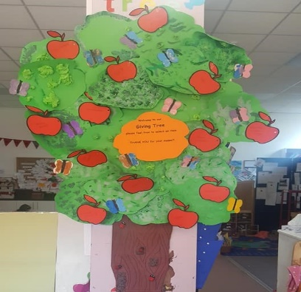

Snack donation

We provide a healthy snack in the morning (breakfast based) and the afternoon. Whilst we do not make additional charges for this we do suggest a voluntary donation of £2 per child per week to contribute towards this cost. Please use bank transfer rather than cash (details on fees page) giving your child’s name as a reference. Thank you!

Equipment and uniform

Uniform isn’t compulsory, but ‘dress for mess’ is! Children getting messy is really important for their development, despite us having plenty of aprons they will get paint, chalk etc. on their clothing. If you would prefer to buy hard wearing uniform this is the link:
https://myclothing.com/ladybirds-pre-school/9964.school
There is a range of colours available to offer choice to children – all with our lovely ladybird logo. We advise ordering early as demand is high in August/September. We do hold a small amount of pre-loved uniform, do contact us if you need some.

Please send your child with the following in their own named bag:
- Full change of clothes: Including pants and socks (your child may get wet outside or when playing in the water tray, or get covered in paint)
- Wellie Boots for outside play, and a pair of shoes for inside as their boots will get muddy from outside, and it is unsafe to be inside in just socks
- Named sun hat (Summer Term)
- Suitable outdoor coat (even if you travel to school in the car as the children have access to outside play throughout the sessions)
- Hat, gloves etc (Winter/Spring Term)

Please ensure all items are clearly labelled with your child’s name – you can leave the bag at preschool if you wish – please let us know if you need to collect wellies etc. when you pick up each time.
Arrival at preschool
We have a one way system for arrival a preschool. Please ensure that you are allowing distance between yourself and other children/adults and that your child is too. We appreciate that siblings may be keen to try out the garden and bikes but respectfully request that you do not allow this.
Handwash units are outside of preschool. We ask that all children wash their hands before coming in to preschool, please help them to do so – making lots of lovely bubbles!
When you have dropped your child off, we ask you to continue via our one way system – around the back of the building.
This is a fairly busy time so please understand that we may not be able to spend time dealing with queries. If you are happy to wait to the end we can deal with any queries at that point, or we can arrange to speak on the phone or at the end of your child’s session on collection.
We are very skilled at supporting children that are a little unsettled, this can be a big step and some children may be anxious – parent too! Rest assured that we will work with you to support this exciting stage for your child – every child is different and we understand this. However, we may be limited if any restrictions (e.g. during the Coronavirus Pandemic) are in place but we have build experience and ideas to help and have supported many a child to settle and have a positive experience when leaving parents/carers for the first time.

Helpful tips and things to remember
Do
- Do label everything including lunch boxes. Do put lunch items in containers the children can manage themselves. You could have a lovely indoor picnic with your child to practise!
- Do check your child's Tapestry account daily, we will use this for all communication including any accidents your child has had, so it is important to be in the habit of checking. If you have any problems accessing it just let us know, we can help!
- Do provide wet weather gear on wet days and sunhats on dry days. If you don't have any, let us know. We have a limited amount we can lend long term. Do provide shoes if they arrive wellies and do let them practise putting them on themselves. We do not permit sandals or open shoes for health and safety reasons.
- Do ensure that you have applied an ‘all day’ sun screen to your child on any sunny days.
- Do provide a named water bottle. We will keep it in preschool and wash/fill it each day. We have some to buy @ £1.50)
- Do maintain social distancing of 2 meters for you AND your children on arrival and collection at preschool
- Do telephone if you have any questions or want to 'check in' on how your child is.
- Do provide named spares for your child in case of accidents.
- Do let us know any changes in your household. E.g. if you child’s sleep pattern has changed, as this may affect them in preschool.

Don’t
- Please don't send your child if they are under the weather. There are lots of childhood minor illnesses that are nothing to worry about but during these times it is sensible to be extra cautious. Do let us know though.
- Don't send children with objects from home, unless specifically arranged with Manager
- Don't put sweets, chocolates or unhealthy choices in your child's lunch, our Healthy Eating Policy will explain more and our Healthy Early Years settings gurus are available for tips, advice and suggestions.
- Please don’t send children in sandals, open shoes, jewellery such as hooped earing (studs are fine), when children are running around and climbing etc. their safety is a priority.

Lastly…..

We have tried to include necessary useful information but if we have missed anything please let us know! We have comprehensive policies on all aspects of our provision which can be found on our website or emailed upon request.
We hope that you and your child will soon feel part of our Ladybirds Preschool ‘family’ – exciting times are ahead!
Best wishes
Diana Buckell BA (Hons)
Manager
Key preschool contacts:
Diana Buckell | Manager | Designated Safeguarding Lead
Jade Parker | Deputy | Special Educational Needs and Disabilities Co-ordinator
Emily Payne | Preschool Administrator | Accounting/invoicing

You may like to add your child’s key person details here:
My child’s Group | My Child’s Key Person | My Child’s Co-person

Notes, questions or comments section

____________________________________________________________________________________________________________________________________________________________________________________________________________________________________________________________________________________________________________________________________________________________________________________________________________________________________________________________________________________________________________________________________________________________________________________________________________________________________________________________

